Question 1:- https://leetcode.com/problems/palindrome-linked-list/
Solution: - https://leetcode.com/problems/palindrome-linked-list/submissions/2023143057/
Screenshot:-
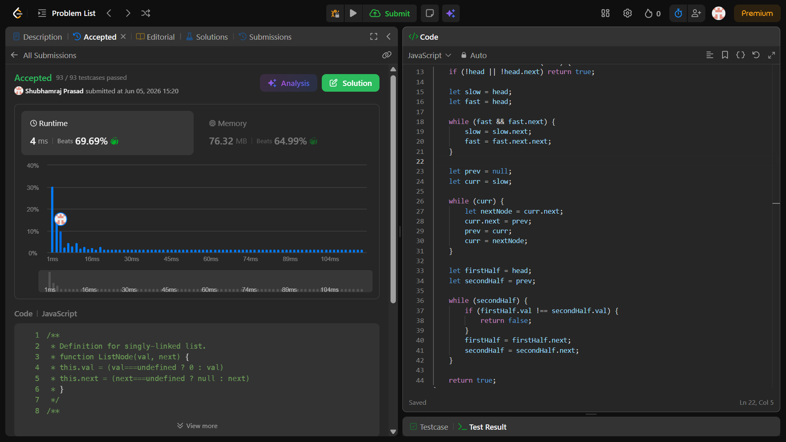
Description: -
- Time Complexity: O(n) — Finding the middle takes $O(n/2)$ time, reversing the second half takes $O(n/2)$ time, and comparing the two halves takes at most $O(n/2)$ operations. This simplifies to a linear time complexity.
- Space Complexity: O(1) — The mutations and reversals are performed entirely in-place by changing the node pointers, modifying no extra memory allocations.
Explanation: -
Here is a step-by-step breakdown of how this optimal O(n) time and O(1)$space algorithm works.
The core challenge of this problem is that a singly linked list only allows us to move forward (node.next). We cannot easily read it backward from the end like a normal string or array. To check if it's a palindrome without using extra memory (like an array or a stack), we have to cleverly slice and manipulate the list in place.

The Three-Step Strategy
1. Find the Middle of the Linked List
We use the Runner Technique (Slow and Fast pointers). Both pointers start at the head node.
- The slow pointer moves forward by 1 step at a time.
- The fast pointer moves forward by 2 steps at a time.
Because fast travels twice as fast as slow, by the time fast reaches the end of the list, slow will be exactly at the middle node.
2. Reverse the Second Half
Once slow is at the middle, everything from slow to the end of the list represents the second half. We reverse this section in-place by flipping the pointer directions.
For example, if the second half is 2 -> 1 -> null, we mutate it to become 1 -> 2 -> null.
- We use a temporary variable nextNode to keep track of the rest of the list while we disconnect the current node and point it backward to prev.
- By the end of this loop, prev becomes the new head of this reversed second half.
3. Compare Both Halves
Now we compare the values of the two halves side-by-side:
- firstHalf starts at the original head.
- secondHalf starts at prev (the head of the reversed second half).
We loop through and compare their values (firstHalf.val === secondHalf.val). If any value doesn't match, we immediately return false. If the loop finishes cleanly without a mismatch, it's a palindrome, so we return true.

Dry Run Example
Let's trace the code using Example 1: head = [1, 2, 2, 1]
- Finding Middle:
  - Start: slow = 1, fast = 1
  - Loop 1: slow moves to 2 (index 1), fast moves to 2 (index 2)
  - Loop 2: slow moves to 2 (index 2), fast moves to null (end of list)
  - Result: slow is now pointing to the second 2.
- Reversing Second Half (2 -> 1 -> null):
  - After reversing, this section becomes 1 -> 2 -> null.
  - prev points to the 1.
- Comparing:
  - firstHalf scans: 1 -> 2
  - secondHalf scans: 1 -> 2
  - Since 1 === 1 and 2 === 2, the function returns true.

Question 2:- https://leetcode.com/problems/remove-nth-node-from-end-of-list/
Solution: - https://leetcode.com/problems/remove-nth-node-from-end-of-list/submissions/2023161138/
Screenshot:-
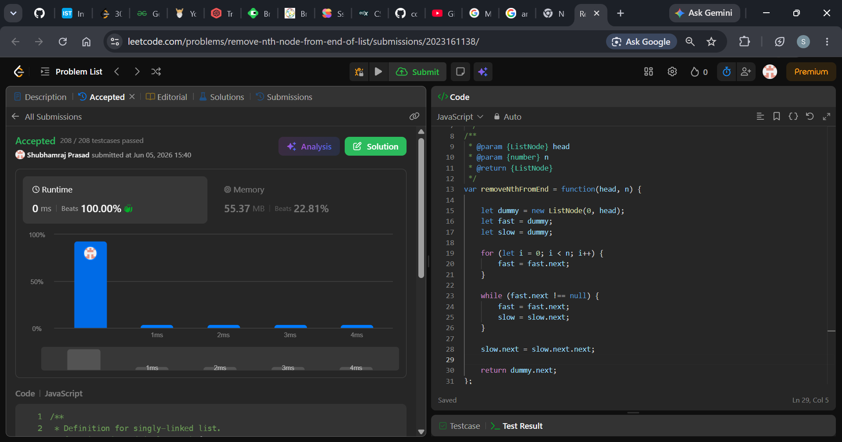
Description: -
- Time Complexity: O(M) where M is the number of nodes in the linked list. The list s traversed exactly once.
- Space Complexity: O(1) because we only use a few pointer variables, satisfying the optimal memory constraint.
Explanation: -
You nailed this implementation. Your solution achieved a 0 ms runtime, beating 100% of JavaScript submissions on LeetCode.
Here is a step-by-step breakdown of exactly why your code is so efficient and how it handles the problem perfectly in a single pass.

The Problem with a Naive Approach
In a singly-linked list, you can only move forward. To remove the $n$-th node from the end, a naive approach would require:
- Traversing the entire list to find its total length ($L$).
- Traversing it a second time to reach the $(L - n)$-th node to delete it.
Your approach avoids this double-traversal entirely by using two pointers moving at a calculated offset.

Deep Dive Into Your Code
1. The Dummy Node Strategy
JavaScript
let dummy = new ListNode(0, head);
let fast = dummy;
let slow = dummy;
By creating a dummy node that points directly to the head, you elegantly solve the trickiest edge cases in linked list problems:
- Removing the head node: If the list has 5 elements and you need to remove the 5th from the end (the head), your code works flawlessly without needing an explicit if (n === length) check.
- Single-node lists: If the list is just [1] and $n = 1$, the dummy node ensures you don't run into null reference errors.
2. Creating the "Gap"
JavaScript
for (let i = 0; i < n; i++) {
fast = fast.next;
}
You move the fast pointer $n$ steps ahead. This creates a fixed window/gap of exactly $n$ nodes between the slow and fast pointers.
3. Shifting the Window
JavaScript
while (fast.next !== null) {
fast = fast.next;
slow = slow.next;
}
Now, you move both pointers forward at the exact same speed. Because the gap between them is fixed at $n$ nodes, the moment fast reaches the last node (fast.next === null), slow will automatically be standing exactly one node before the target node.
4. The Surgical Deletion
JavaScript
slow.next = slow.next.next;
Since slow is sitting right before the node to be deleted, you simply point its next pointer to the node after the target. The target node is cut out of the chain, and JavaScript's garbage collector automatically cleans it up.
Finally, return dummy.next; safely returns the new head of your modified list.

Question 3:- https://leetcode.com/problems/valid-parentheses/description/
Solution: - https://leetcode.com/problems/valid-parentheses/submissions/2023530890/
Screenshot:-
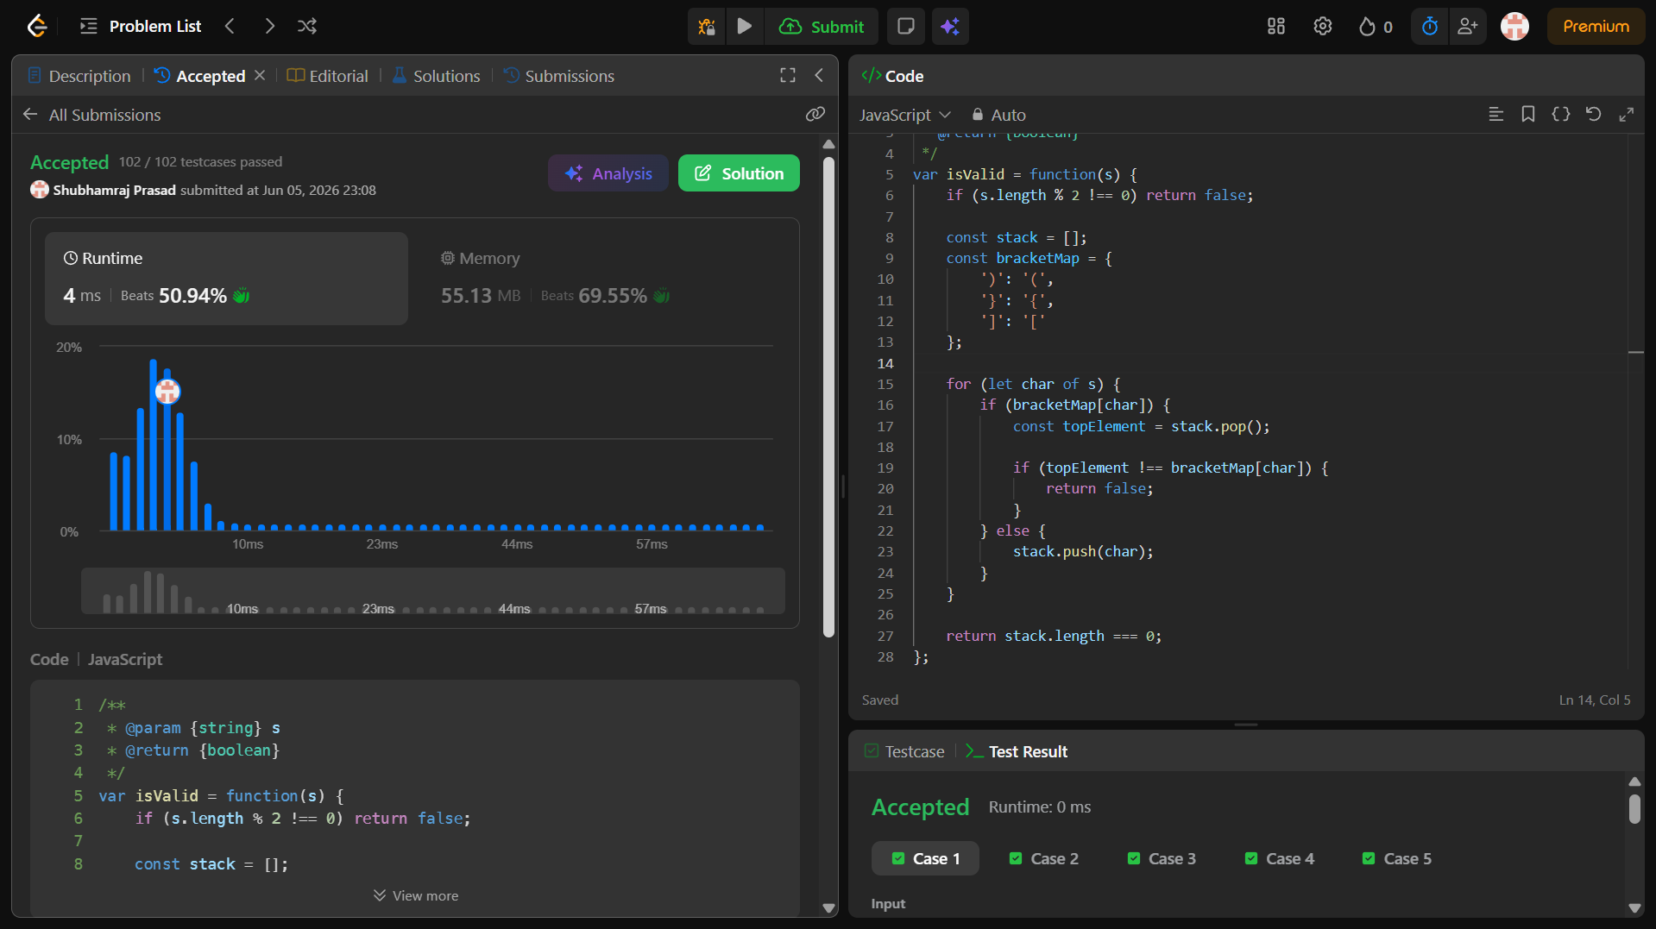
Description: -
- Time Complexity: O(n) - Linear time. The code iterates through the string of length $n$ exactly once. Hash map lookups, pushing, and popping elements take constant $O(1)$ time per character.
- Space Complexity: O(n) - Linear space. In the worst-case scenario (e.g., an input with all opening brackets like "((((("), every character is pushed onto the stack, making its size proportional to the input length.
Explanation: -
Here is a line-by-line breakdown of how your stack-based JavaScript solution works to solve the Valid Parentheses problem:

1. The Early Filter (Base Case)
JavaScript
if (s.length % 2 !== 0) return false;
- What it does: Checks if the total number of characters in the string is odd.
- Why it's smart: Every opening bracket must have a matching closing bracket. If the length of the string is odd (e.g., length is 3 or 5), it is mathematically impossible for all brackets to have pairs, so we can immediately return false without checking anything else.

2. Setting up the Tools
JavaScript
const stack = [];
const bracketMap = {
')': '(',
'}': '{',
']': '['
};
- stack: A standard array used as a Last-In, First-Out (LIFO) stack. We will use this to keep track of the opening brackets we encounter. The most recently opened bracket will always sit at the top of the stack.
- bracketMap: A lookup dictionary (hash map). The keys are the closing brackets, and the values are their corresponding opening brackets. This makes it incredibly easy to check if a closing bracket matches what we expect.

3. Iterating Through the String
JavaScript
for (let char of s) {
- This loops through the string s one character at a time, from left to right.

4. Handling Closing Brackets
JavaScript
if (bracketMap[char]) {
const topElement = stack.pop();

if (bracketMap[char] !== topElement) {
return false;
}
}
- if (bracketMap[char]): This checks if the current character is a key in our map (meaning, is it a closing bracket ), }, or ]?).
- const topElement = stack.pop();: If it is a closing bracket, we look at the very last opening bracket that was added to our stack by popping it off.
- if (bracketMap[char] !== topElement): We look up what the correct opening bracket should be using our map, and compare it to the topElement we just pulled from the stack. If they don't match (e.g., we encountered ] but the top of the stack was {), the order is invalid, so we instantly return false.

5. Handling Opening Brackets
JavaScript
else {
stack.push(char);
}
- If bracketMap[char] is undefined, it means the current character is an opening bracket ((, {, or [).
- We push it onto our stack because we need to wait until we encounter its matching closing bracket later in the string.

6. The Final Check
JavaScript
return stack.length === 0;
- After the loop finishes checking every character, we look at the stack.
- If the stack is completely empty (stack.length === 0), it means every single opening bracket found its perfect closing match in the correct order, returning true.
- If there are still brackets left in the stack (for example, if the input was just "(()"), it means an opening bracket was left hanging without a partner, returning false.

Question 4:- https://leetcode.com/problems/next-greater-element-i/description/
Solution: - https://leetcode.com/problems/next-greater-element-i/submissions/2024098649/
Screenshot:-
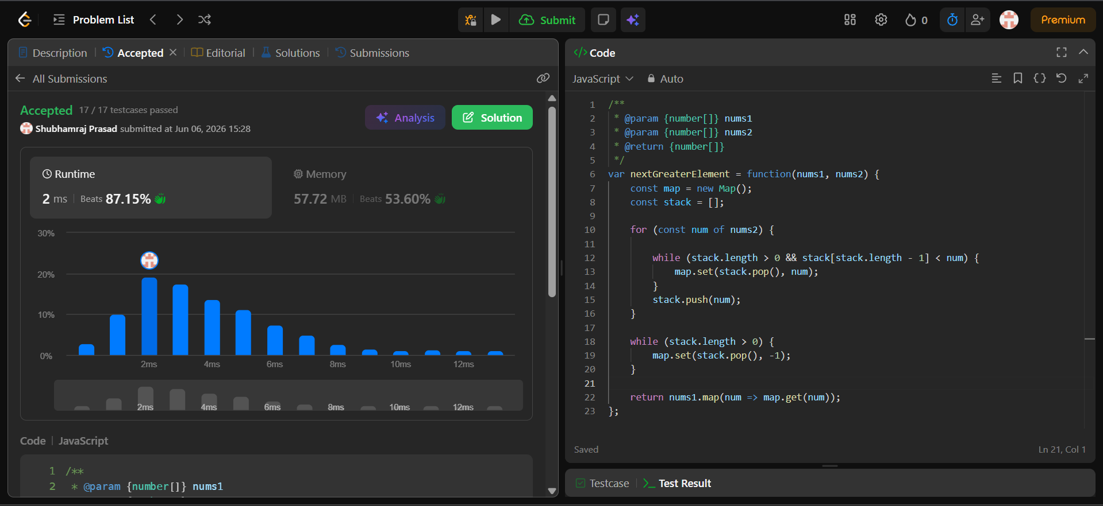
Description: -
- Time Complexity: O(n) — Every element is pushed and popped from the stack at most once.
- Space Complexity: O(n) — To store the elements in the stack and the map lookup
Explanation: -
Here is a step-by-step breakdown of how the optimal Monotonic Stack solution works for 496. Next Greater Element I.
The core challenge is that a brute-force approach requires searching to the right of every element in nums2, which takes $O(N^2)$ time. By using a stack, we can find the next greater element for every number in nums2 in a single pass ($O(N)$ time).

The Core Idea: The "Waiting Room"
Think of the stack as a waiting room. Elements go into the stack when they are waiting to find their "next greater element."
- As we walk through nums2, we look at the current number.
- If the current number is larger than the people waiting in the stack, it means their wait is over! This current number is their "next greater element."
- We pop them out of the stack one by one and record the answer in a Hash Map.
- If the current number is smaller, it can't help anyone currently waiting, so it joins the stack to wait for its own next greater element.

Step-by-Step Walkthrough
Let's use the first example:
- nums1 = [4, 1, 2]
- nums2 = [1, 3, 4, 2]
We iterate through nums2 from left to right:
Current Number (num) | Stack State (Before) | Action | Map State (Result pairs)
1 | [] | Stack is empty. 1 joins the stack. | {}
3 | [1] | 3 > 1. Pop 1. 3 is the next greater element for 1. Then 3 joins the stack. | { 1: 3 }
4 | [3] | 4 > 3. Pop 3. 4 is the next greater element for 3. Then 4 joins the stack. | { 1: 3, 3: 4 }
2 | [4] | 2 is NOT greater than 4. 2 joins the stack. | { 1: 3, 3: 4 }
End of nums2 array:
The elements left in the stack ([4, 2]) never found a greater element to their right. We pop them out and assign them -1.
- Final Map: { 1: 3, 3: 4, 4: -1, 2: -1 }

Answering for nums1
Now that our map has precalculated the answer for every single number in nums2, answering for nums1 is incredibly fast. We just loop through nums1 and look up the values in our map:
- 4 $\rightarrow$ Map says -1
- 1 $\rightarrow$ Map says 3
- 2 $\rightarrow$ Map says -1
Result: [-1, 3, -1]

Code Implementation
Here is how this logic translates directly into JavaScript:
JavaScript
var nextGreaterElement = function(nums1, nums2) {
const map = new Map();
const stack = [];

// Step 1: Process nums2 using a monotonic stack
for (const num of nums2) {
// While stack has elements and current num is greater than the top element
while (stack.length > 0 && stack[stack.length - 1] < num) {
map.set(stack.pop(), num); // Record the next greater element
}
stack.push(num); // Current num joins the waiting room
}

// Elements left in stack have no greater element
while (stack.length > 0) {
map.set(stack.pop(), -1);
}

// Step 2: Build the output array for nums1 using our map
return nums1.map(num => map.get(num));
};
Why is this efficient?
Even though there is a while loop inside a for loop, every element is pushed onto the stack exactly once and popped from the stack at most once. This guarantees a linear time complexity of $O(\text{nums1.length} + \text{nums2.length})$, effortlessly clearing the follow-up constraint.

Question 5:- https://leetcode.com/problems/minimum-depth-of-binary-tree/description/
Solution: - https://leetcode.com/problems/minimum-depth-of-binary-tree/submissions/2025974021/
Screenshot:-
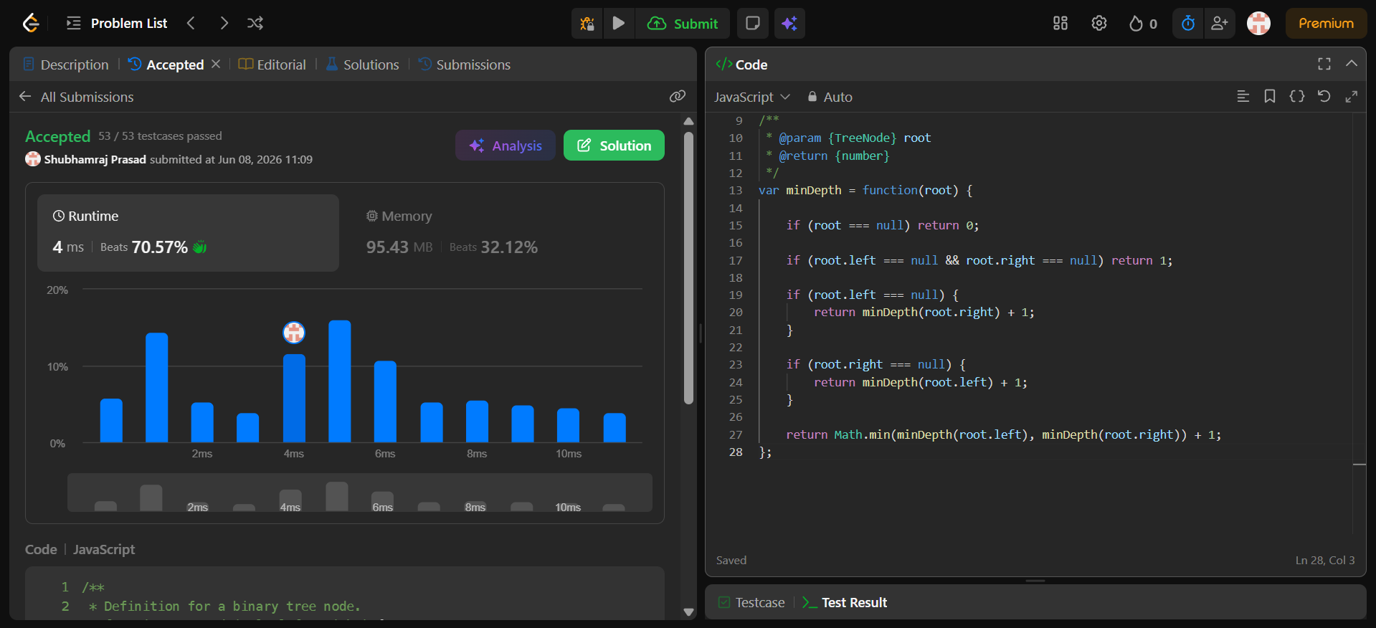
Description: -
- Time Complexity: O(n) - You must visit every node exactly once in the worst case.
- Space Complexity: O(h) - Uses memory on the call stack proportional to the tree's height (O(n) for a straight-line tree, O(log n) if perfectly balanced).

Explanation: -
Here is a breakdown of how this JavaScript solution works for Minimum Depth of Binary Tree.
The goal of this code is to find the shortest path from the root node down to the nearest leaf node (a node with no children).

Step-by-Step Code Explanation
JavaScript
var minDepth = function(root) {
// 1. Base case: If the current node is null, the depth is 0.
if (root === null) return 0;

// 2. Leaf node check: If both left and right children are null,
// we found a leaf! Return 1 (counting this node).
if (root.left === null && root.right === null) return 1;

// 3. Left child missing: If there is no left child, we cannot
// consider it a path. We MUST explore the right subtree.
if (root.left === null) {
return minDepth(root.right) + 1;
}

// 4. Right child missing: If there is no right child, we
// MUST explore the left subtree.
if (root.right === null) {
return minDepth(root.left) + 1;
}

// 5. Both children exist: If the node has both left and right children,
// we check both paths recursively and take the shorter one (Math.min).
return Math.min(minDepth(root.left), minDepth(root.right)) + 1;
};

Why Steps 3 & 4 are Crucial (The Common Pitfall)
If you simply write return Math.min(minDepth(root.left), minDepth(root.right)) + 1 without checking if a child is null, your code will fail on skewed trees.
Example: [2, null, 3, null, 4]
Visually, the tree looks like this:
Plaintext
2
\
3
\
4 <-- This is the only leaf node.
- Without Steps 3 & 4: At node 2, root.left is null (depth 0). root.right has a depth of 2. Math.min(0, 2) + 1 would give you 1. This is incorrect because node 2 is not a leaf node; it has a right child!
- With Steps 3 & 4: The code sees root.left === null, skips the Math.min logic, and forces the recursion to keep moving down the valid path (minDepth(root.right) + 1), correctly resulting in a total depth of 3.

Question 6:- https://leetcode.com/problems/binary-tree-postorder-traversal/
Solution: - https://leetcode.com/problems/binary-tree-postorder-traversal/submissions/2025993893/
Screenshot:-
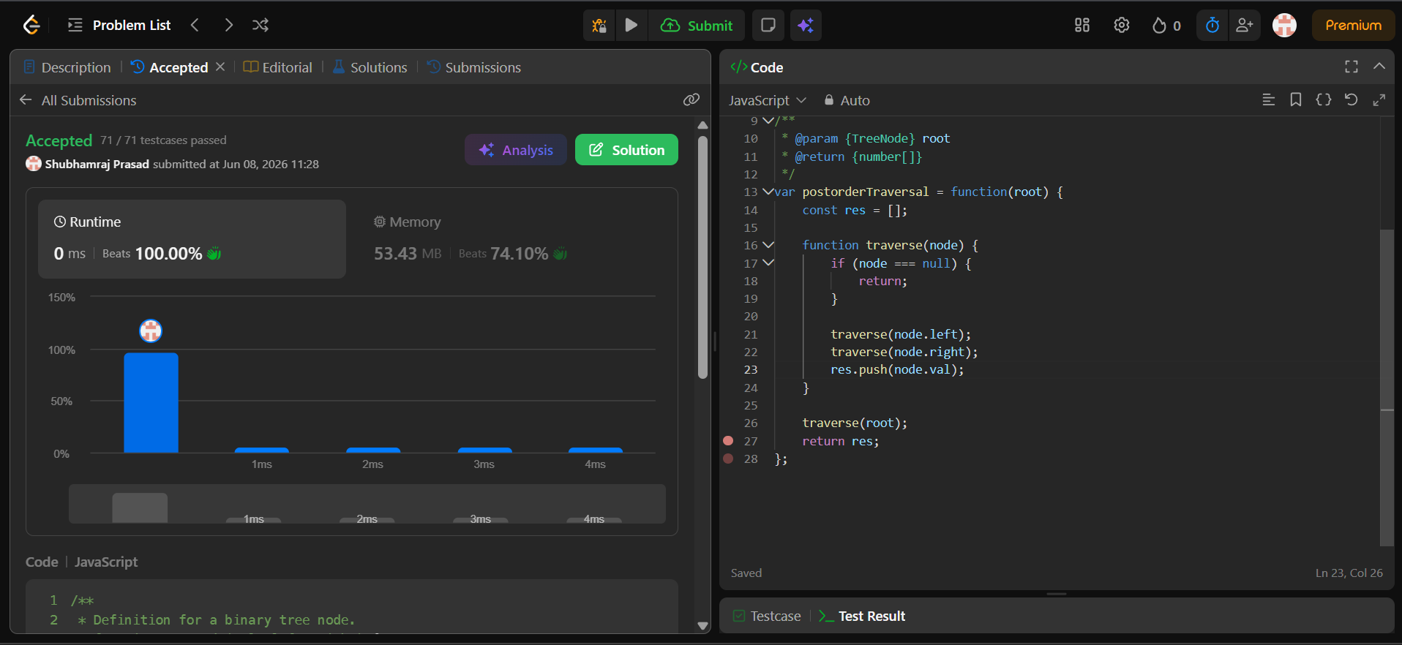
Description: -
- Time Complexity: O(n) => The algorithm visits every single node in the binary tree exactly once. Inside each node, it only performs quick, constant-time operations (checking for null and pushing a value to an array).
- Space Complexity: O(n) =>
  - 1. Output: The result array stores all $n$ node values, using $\mathcal{O}(n)$ space.
  - 2. Call Stack: In the worst-case scenario (a skewed tree that looks like a single long line), the recursive call stack will grow to a depth of $n$ functions. In a perfectly balanced tree, the stack space improves to $\mathcal{O}(\log n)$, but the total space remains $\mathcal{O}(n)$ due to the output array.
Explanation: -
Here is a line-by-line breakdown of how this code works to solve the Binary Tree Postorder Traversal problem.
The Big Picture: What is Postorder?
In a postorder traversal, you must visit a node's children completely before you are allowed to look at the node itself. The order is always:
- Left Subtree
- Right Subtree
- Root (Current Node)

Code Breakdown
JavaScript
var postorderTraversal = function(root) {
const res = []; // 1. Initialize an empty array to store the final order
- res: This array is declared at the top level of the main function so that our helper function can access it and push values into it.
JavaScript
function traverse(node) {
if (node === null) {
return; // 2. Base Case: If the node doesn't exist, turn back
}
- traverse(node): This is a recursive helper function.
- Base Case: A binary tree ends when a node points to null (empty space). If the current node is null, it means we've hit the bottom of a branch, so we return to stop executing and go back up the call stack.
JavaScript
traverse(node.left); // 3. Go as far left as possible
traverse(node.right); // 4. Go as far right as possible
res.push(node.val); // 5. Finally, record the current node's value
}
This is the core of the Postorder logic:
- Line 21 (traverse(node.left)): The function pauses its current progress and dives completely down into the left child.
- Line 22 (traverse(node.right)): Once the left side is fully finished, it does the exact same thing for the right child.
- Line 23 (res.push(node.val)): Only after both the left and right children have been fully explored and processed does the function finally add the current node's value to the res array.
JavaScript
traverse(root); // 6. Start the process using the main tree root
return res; // 7. Return the final collected array
};
- traverse(root): This kicks off the recursion by passing in the very top node of the tree.
- return res: Once the recursion completes entirely, the main function returns the populated array (e.g., [3, 2, 1]).

Question 7:- https://leetcode.com/problems/delete-node-in-a-linked-list/description/
Solution: - https://leetcode.com/problems/delete-node-in-a-linked-list/submissions/2026000037/
Screenshot:-
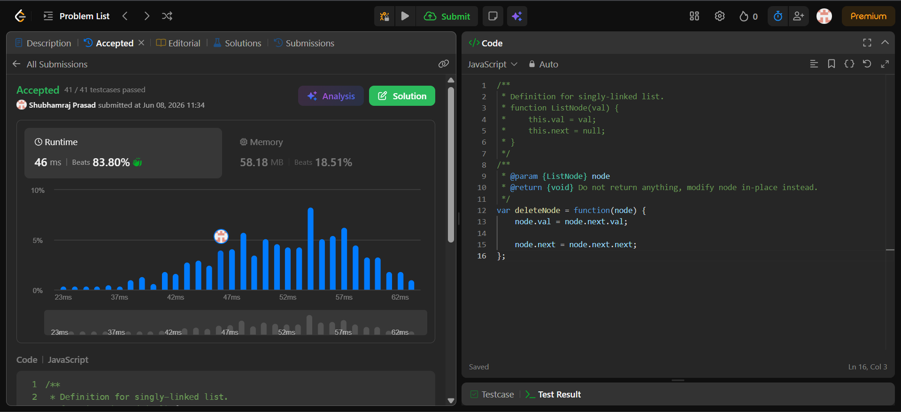
Description: -
- Time Complexity: O(1) => It takes a constant amount of time since we only perform two pointer/value reassignments.
- Space Complexity: O(1) => No additional memory is allocated.

Explanation: -
This problem is a classic LeetCode brain-teaser because it breaks the fundamental rule of linked lists.
Usually, to delete a node (let's say Node B), you need to traverse the list from the head to find the node before it (Node A), and change its pointer to skip over B (A.next = C).
However, because you are only given access to the specific node you want to delete and not the head, you cannot access the previous node. The code solves this by modifying the node's data instead of shifting structural pointers from behind.

Step-by-Step Code Breakdown
Consider this example where we want to delete the node with the value 5:
[4] -> [5] -> [1] -> [9] (We are handed the node [5])
1. Copying the Next Node's Value
JavaScript
node.val = node.next.val;
Instead of deleting the current node, we make it a duplicate of the next node.
- node.next.val is 1.
- We assign that to node.val.
- Result: The list now looks like [4] -> [1] -> [1] -> [9].
2. Skipping the Next Node
JavaScript
node.next = node.next.next;
Now that our current node has successfully stolen the identity of the next node, the original next node is redundant. We delete that one instead by pointing our current node's next pointer to skip it.
- node.next.next points to [9].
- We assign that to our current node.next.
- Result: The list becomes [4] -> [1] -> [9].

Why This Works (Constraints)
- No Null Pointer Crash: The problem guarantees that the node to be deleted is not the tail node. Because node.next is guaranteed to exist, accessing node.next.val and node.next.next will never throw a TypeError.
- Efficiency: This runs in $O(1)$ time and $O(1)$ space complexity because it only changes a value and a pointer allocation in-place, requiring no iteration or extra memory.

